*Statistics and Probability Theory in*

*Flipping Coins*

*GEM 605 Activity*

Ivan John A. Naparota

University of San Carlos – Talamban Campus

Department of Electrical and Electronics Engineering

ivanjohnnaparota66@gmail.com

***Abstract* — This activity tries to find a definite answer from a question that gives indefinite possibilities just like the randomness that flipping-coin problems do through statistics and probability theory, a prediction is made through probability theory and experimentation is done after, data were gathered from the experiment and were treated to have a result and be able to compare it to the made prediction. Furthermore, this activity tries to discuss the difference and relationship of probability theory and statistics.**

***Keywords* – *Probability, Statistics, Coin Flipping***

# I. INTRODUCTION

Statistics is a branch of [mathematics](https://en.wikipedia.org/wiki/Mathematics) dealing with the collection, analysis, interpretation, presentation, and organization of data [1] and probability is the [measure](https://en.wikipedia.org/wiki/Measure_(mathematics)) of the likelihood that an [event](https://en.wikipedia.org/wiki/Event_(probability_theory)) will occur [2]. Though they may have different approaches on giving a definite answer to a problem that normally gives indefinite possibilities of results, probability theory and statistics can work hand in hand for a common problem.

In this activity, it is told to guess the average coin flips before getting three consecutive heads as a result and doing an experiment to see the actual outcome, it is then tabulated and discussed.

Guessing how many coin flips before getting three consecutive heads as a result is one of the problems that can be aided with probability and statistics. As we all know, flipping a coin can either result to a head or a tail, getting three consecutive heads with no definite range of tosses could be a tricky one to answer without leaning on probability and statistics.

With this activity, we would be able to experience it first hand what probability and statistics could do to problems like this.

# II. TOOLS AND OPERATIONS

#### A. “And” Probability – Independent

When we have a situation where we want to find the probability of two or more events occurring, and we are sure that both events must occur, this is the “and” case. The math is simple for the “and” case – it is basic multiplication of the probabilities of the two individual, independent, events (the word *independent* is important and it means that one of the events does not have to happen before the other, they occur with or without the other event occurring[3].

The equation for two independent “and” events is:

P(A and B and C) = P(A) x P(B) x P(C) [3]

#### B. Arithmetic Mean Formula

The arithmetic mean of a set of values is the ratio of their sum to the total number of values in the set. Thus, if there are a total of *n* numbers in a data set whose values are given by a group of *x*-values, then the arithmetic mean of these values, represented by 'm', can be found using this formula[4].

|  |
| --- |
| null |

#### C. Histogram

A graph of a frequency distribution in which rectangles with bases on the horizontal axis are given with widths equal to the class intervals and heights equal to the corresponding frequencies[5].

III. METHODOLOGY

First without experimenting, predict the number of tosses necessary to get three (3) consecutive heads as a result using the formula found in IIA.

After that, do the actual random experiment and get one hundred (100) outcomes considering three (3) consecutive heads as one (1) outcome. Record your result and make a tabulated data of the experiment. Added to that, make a histogram or a frequency plot of the experiment and record the span of time needed to finish the experiment.

Obtain the average number of tosses using the arithmetic mean formula in IIB and compare it with the prediction made.

IV. RESULTS AND DISCUSSIONS

Letting P(A) = 0.5 ; P(B) = 0.5 ; P(C) = 0.5, and using the formula in IIA, the prediction made was eight (8) tosses before getting three (3) heads consecutively. However, doing the experiment and computing the average tosses afterwards through formula IIB will give a result of 10.84 tosses.

The experiment took 51 minutes 42 seconds for it to be finished.

The histogram or frequency plot is shown below in Drawing1, the graph shows that some number of tosses to achieve an outcome may be the same, leading in number is three (3) tosses with seventeen (17) outcomes, followed with four (4) having eleven (11) outcomes, thirteen (13) with ten (10) outcomes and so on. And as shown, the highest number of tosses is thirty three (33) tosses followed with thirty one (31), thirty (30) and so on.

Drawing1. Histogram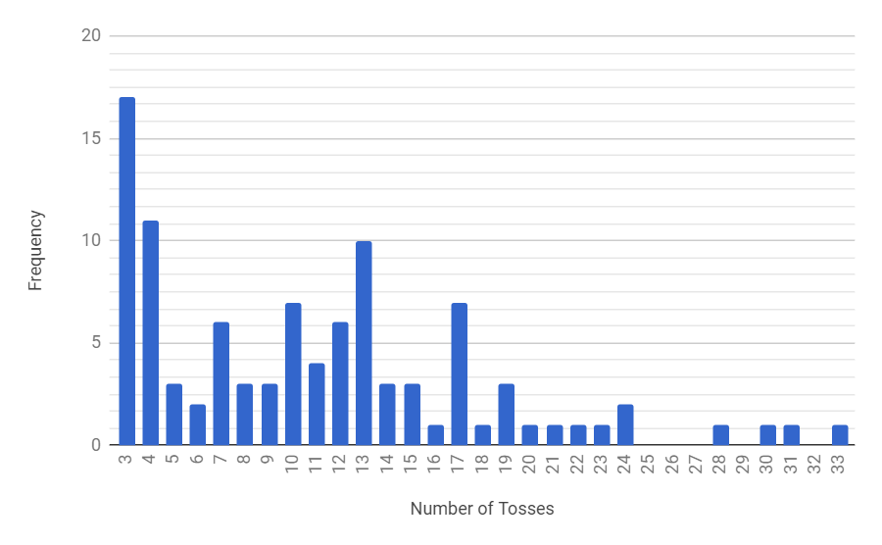

V. CONCLUSIONS

The predicted number of tosses varies with the average number of tosses that was computed after doing the actual tossing of coin. Though they were not exactly the same, they still have a closer margin with each other.

Still, this activity shows that using probability theory you can make a guess and be able to deliver a definite answer from a problem that has indefinite set of possible answers even without the help of experimentation, while statistics needs gathering of data, in this case through experimentation, processing and recording of data, treating the data with the necessary tools and operations, and graphing the data to achieve a more convincing result.

##### VI. REFERENCES

[1] Dodge, Y. (2006) The Oxford Dictionary of Statistical Terms, Oxford University Press. [ISBN](https://en.wikipedia.org/wiki/International_Standard_Book_Number) 0-19-920613-9

[2]Webster's Revised Unabridged Dictionary. G & C Merriam, 1913

[3]http://www.makemathagame.com/math-concepts/probability-and/

[4]http://study.com/academy/lesson/arithmetic-mean-definition-formula-example.html

[5]http://www.dictionary.com/browse/histogram